1. Suppose two hosts , A and B are separated by 10,000 Kilometres and are connected by a direct link of R=1 Mbps. Suppose the propagation speed over the link is 2*108meters/sec. Consider sending a file of 600,000 bits from Host A to Host B.
2. Suppose the file is sent continuously as one big message. How long does it take to send the file, assuming it is sent continuously?

Sol:

By data,

Number of hops ( A and B) = 2

Distance between the hops, d= 10000 Kilometres

Speed of link connected, R= 1 Mbps

Length of file, L= 600000 bits

Speed of propagation, s =2*108meters/sec

As per the assumption the file is sent continuously as a single big message. The total time take is the sum of transmission time and propagation time.

Transmission time= L÷R

= 600000 ÷ (1*(106)

=0.6 sec

Propagation time= d ÷ s

= (10000*103) ÷ (2*108)

=0.05 sec

Total time taken= dpropagation + dtransmission

= 0.05 Sec + 0.6 Sec

= 0.65 sec

So the total time taken to send a single file of 600000 bits continuously=0.65 Sec.

1. Suppose now the file is broken up into 30 packets with each packet containing 20,000 bits. Suppose that each packet is acknowledged by the receiver and the transmission time of an acknowledgement packet is negligible. Finally, assume that the sender cannot send a packet until the preceding one is acknowledged. How long does it take to send the file?

Sol:

In this case the total time taken is the sum of transmission time of packet, propagation time of packet, transmission time of acknowledgement and propagation time of acknowledgement.

Total Time = dtrans of packet+ dprop of packet+ dtrans of ack+ dprop of ack.

Length of each packet =20000 bits

Number of packets =30

Distance between the hops, d= 10000 Kilometres

Speed of propagation, s =2*108meters/sec

Propagation time of each packet, dprop of pack =d÷s

=(10000*1000)÷( 2*108 )

= 0.05 sec

Transmission time of each packet, dtrans of packet=L÷R

=20000÷(1*106)

=0.02 sec

The total delay for each packet = dprop of pack + dtrans of packet

=0.05+0.02

=0.07 Sec

Propagation time for acknowledgement, dprop of ack= d÷s

=(10000*1000)÷( 2*108 )

= 0.05 sec.

Transmission time for acknowledgement, dtrans of ack=0(negligible)

So the total time for each acknowledgement= dprop of ack + dtrans of ack

= 0.05 + 0

=0.05 sec.

Therefore total time for each acknowledged packet transmission is dtrans of packet+ dprop of packet+ dtrans of ack+ dprop of ack.

Total time for each packet = 0.07 + 0.05 = 0.12 sec

For 30 packets total time = 30*0.12 = 3.60 sec

c.) calculate the bandwidth delay product, R*tprop .What does it mean?

Sol:

Link speed, R= 1*106

Propagation time, dprop =d/s

= (10000*1000) ÷ (2*108)

= 0.05 sec.

Bandwidth delay product = 0.05*1*106

= 50 kb

**Bandwidth delay product:-**

Band width delay product gives the maximum amount of data that can be transmitted over a network. If the amount of data sent by the transmitter is less than the bandwidth delay product then it means that the link is not being used at his peak capability which may sometimes result in inefficient use of link.

d.) If there are two routers between A and B and both have 1 Mbps links, how long does it take to send the file?

Sol:

B

**A**

L L L

There are two routers present in between hosts A and B .so the total transmission time taken will be (L÷R)+ (L÷R)+ (L÷R)= 3L÷R

=(3*20000)÷(106)

=0.06 Sec.

Propagation time for each packet, dprop of packet=d÷s

=(10000*1000)÷( 2*108 )

= 0.05 sec

Transmission time for acknowledgement, dtrans of ack = 0(negligible)

Propagation time for acknowledgement, d prop of ack = d/s

= (10000*1000) ÷ (2*108)

= 0.05 sec.

Therefor the total time taken for transmission of each acknowledged packet is dtrans of packet+ dprop of packet+ dtrans of ack+ dprop of ack.

Total time = (3L÷R) + (d÷s) + (0) + (d÷s)

= (0.06) + (0.05) + (0) + (0.05)

= 0.16 Sec.

For 30 packets total time taken = 30*0.16 = 4.8 Sec

2)Read articles on two internet pioneers from <http://www.ibiblio.org/pioneers/index.html>, and write 1~2 paragraph(S) of your personal perspective on each person’s story.

Ans.

**J.C.R.Licklider:**

Licklider most popularly known as Lick contributed more to the internet by his ideas rather than inventions. Lick’s ideology in the field of computers was innovative even though he was a student from a psychology background. Coming to the other side of his personality, though being an intellectual, he was better known for his good manners and humbleness. He had a nick name “computing’s Johnny Appleseed”, which was very much apt for a person like him who foresaw computer’s importance in daily life.

‘Man Computer Symbiosis’, an amazing paper presented by him clearly explained the need for evolution of computers. His experiment really sounded interesting to me as he himself made him as a subject .It insisted on the concept of cooperation between man and a computer which was truly a revolutionising idea. Lick’s experiment demonstrated the roles to be performed by a computer and the instances which actually needed human assistance and interference. Lick made the BBN, a normal designer firm to use computers at early stages of its inception and later made it to supply the computer’s to prestigious ARPANET. Later on when he moved into ARPANET he encouraged and brought together nearly a dozen of universities and companies and named them as Intergalactic Computer Network, which later became the core of ARPANET.

His book ‘Libraries of the future’, which dealt with the electronic information storage sounded really interesting to me .Lick predicted the importance of various concepts like electronic storage in the very beginning of 60’s and there by lead strong foundation to the development of today’s world of computing.

**Bob Metcalfe:**

Metcalfe, the founder of Ethernet faced many failures in his career. Even though he never let it off and succeeded and invented Ethernet which made him one of the pioneers of today’s world of internet. Bob had published a good informative pamphlet which grabbed the attention of AT & T officials, who later took a virtual tour along with him. Though he did not complete his presentation successfully he realised the significance of a circuit switched network.

It was Bob’s determination that encouraged me to write about him. Though he underwent failure during his Ph.D. he never let it off. He read a paper on ALOHA network and later suggested the changes which drastically improved the performance of ALOHA system. He suggested to increase the retransmission time based on the traffic load. He then continued his research on this concept and got his Ph.D. degree. He then joined Xerox and by modifying ALOHANET he invented a new concept called Ethernet which layer revolutionised networking.

Bob finally became responsible to introduce a revolutionary method of networking which helped a lot of universities and companies. He then started his own company and offered different services. Though Bob faced many failures it was his determination which made him a unique pioneer of internet.

.

3.Discuss on computer virus, worm, spyware, malware, Trojan horse and botnet.

Ans.

**Computer Virus :**

A computer virus can be defined as a executable program which is capable of replicating itself. A virus is capable of causing damage to the contents of hard disk and may interfere with normal operation of computer. Virus is normally spread through attachments in email messages and instant messages. Virus is broadly categorized into two categories Viz., resident virus which contains replication module and non-resident viruses which contains replication module along with a finder module. Some of the recovery methods that can be implemented after a virus attack include installing antivirus software, using tools like system restore and reinstalling the operating system.

**Worm :**

A worm is a computer program that has the ability to copy itself from machine to machine and replicate itself. It uses up system’s processing time and network bandwidth during its replication process. Unlike virus it has the capability to travel itself without human interference from machine to machine. There are different types of worms like Email worms, Instant messaging worms, Internet worms, IRC worms and file sharing network worms. Among these internet worms cause a massive damage to network. It scans all available network resources and attempts to gain full access over them. Regular Installation of security updates sent by the service providers would reduce the influence of computer worms to some extent.

**Spyware:**

Spyware is malicious software that gathers user’s information without his/her knowledge. They are predominantly used by the advertisers in order to trace out most frequent websites surfed by the user in the internet. They can even redirect the user to another website instead of the website desired by him. It is also termed as privacy-invasive software because of its nature. Spyware results in unwanted usage of processor and there by reduces systems performance. Recovery measures include usage of anti-spyware software. When the spyware attacks become severe then the user has to go for reinstallation of operating system which is often undesirable.

**Trojan horse:**

Trojan horse is a destructive program which often appears as a useful program. The prime purpose of the Trojans is to transfer the access to a unauthorised personality most often termed as a hacker. This term Trojan horse has actually been derived from Greek mythology where it was a cunning act of Greeks to deceive the soldiers of Troy. These Trojan horses usually hide along with the other useful software. The Trojan horses do not have the capability to replicate themselves but have severe impact on the system. The common recovery methods include usage of antivirus software and reinstalling the operating system.

**Botnet:**

Botnet refers to a network of compromised computers that are usually connected over internet whose control and access has been gained by a remote user. Most often the protocols used to control the victim computers are Internet Relay Chat (IRC) and Hypertext Transfer Protocol (HTTP). A computer gets infected by a botnet malware through a computer warm or virus. The effects of botnet are adverse that they can steal most confidential information from the client and transfer it to third party or it even has the capability to crash down the server. A typical botnet constitutes different topologies like star, multi-server, hierarchical and random topologies. Preventive measures include implementation of passive OS finger printing which identifies and alerts the network administrator regarding the issue.

4. Explore IETF webpage and list at least five working groups, Among these working groups choose one of them and summarize its activities in one page i.e., objective of the charter, documents/issues published or discussed in the working group.

Ans.

IETF stands for Internet Engineering Task Force. IETF sets the standards for development processes. Working groups are generally short-term in nature and gets terminated after achieving the specific goals. There are mainly two categories of working groups.

They are 1.Active working group

2. Concluded Working group

Some of the working groups are listed below:

1. Precis – Preparation and comparison of internationalized strings

2. repute – Reputation Services.

3. spfbis – SPF Update.

4. fax – Internet fax

5. beep – Beep Extensible Exchange Protocol

**Beep Extensible Exchange Protocol (beep)**:

Beep Extensible Exchange Protocol is a concluded working group. The chair of this working group is Pete Resnick.

**Objective:**

The objective of the group is to develop a standard-track application protocol framework for connection-oriented, asynchronous request interactions.

**Description:**

Framework designed must allow multiplexing of independent request/response streams on a single transport connection and that design should entertain both textual and binary message formats. BXXP should be used as starting point by the group. If necessary non-backwards compatible changes can be made to BXXP.

**Goals & Milestones:**

* To prepare most up to date specification assessments nad solutions given by the working group.
* To revise and discuss the internet-draft at Pittsburgh IETF.
* To submit the specifications those are revised to IESG for using it as a standards-track publication.

**Request For Comments:**

Mapping the beep core on to TCP (RFC 3081):

It deals with how Blocks Extensible Extension protocol session is mapped on to a single Transmission Control Protocol.

The Blocks extensible Exchange Protocol Core:

It explains a generic application protocol for connection oriented asynchronous interactions termed as beep core which permits simultaneous and independent exchanges.

5. Explore ping and traceroute which are basic tools used to measure the network performance and retrieve the network status. Run ping and traceroute with at least three different hosts and options. Record the commands and their output.

Ans.

**PING:**

PING stands for Packet INternet Gropper. It is used to verify the connection to the host or to ensure that connection established to the host is a valid one. It calculates the round trip delay in communicating with the host and packet loss.

To retrieve network status using ping one has to go the command prompt and then enter the commands desired. The syntax followed is as shown below:

Ping [Option] [Destination]

Some of the options available in ping are

|  |  |
| --- | --- |
| Option | Purpose |
| -t | It pings the specified host until stopped. |
| -w time out | It is used to specify time out in milliseconds it has to wait for each reply |
| -v TOS | It specifies the type of service |
| -I TTL | It specifies the time to live |
| -a | It resolves addresses to host names |
| -l size | Used to send buffer size. |

1.using ping command on [www.google.com](http://www.google.com) with option –t

Command Entered: ping –t goole.com 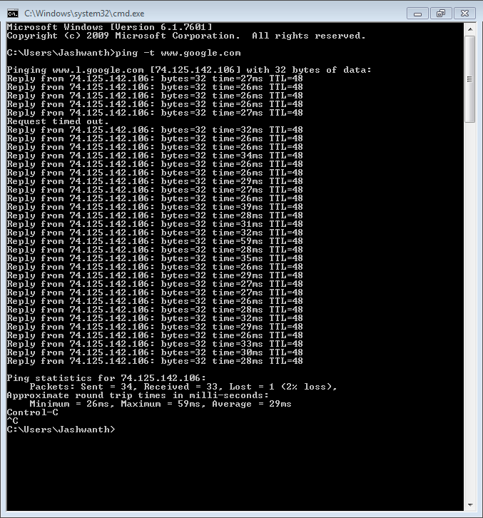

1. Using ping command on [www.oracle.net](http://www.oracle.net) with option ‘–w timeout’

Command Entered: ping –w 2 [www.oracle.net](http://www.oracle.net)

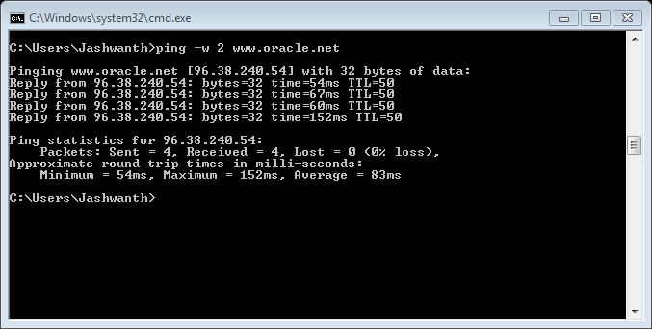

1. Using ping command on [www.umkc.edu](http://www.umkc.edu) with option ‘-v TOS’

Command Entered: ping –v TOS [www.umkc.edu](http://www.umkc.edu)

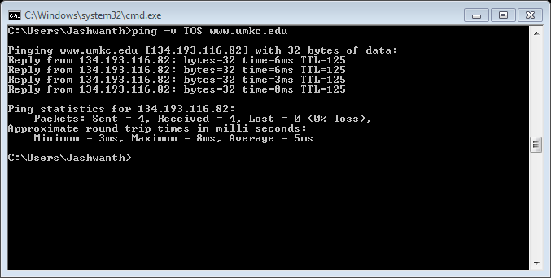

**Traceroute:**

Traceroute is used to find out the path in which the packets are being sent from computer to remote computer. It was designed by Van Jacobson. Traceroute is of immense use in finding out network failures and to give an approximate location where the routing failure has taken place.

In windows the traceroute command is executed in command prompt window and the syntax used is

Syntax: tracert [Destination address]

Like ping there are different options that can be used with the traceroute command. Some of them are listed below.

-w timeout : waits for specified timeout for each reply.

-h maximum_hops: It specifies the maximum number of hops that are to be searched to find out the target.

-d : It is used for not to resolving the addresses to the host names.

-j host-list : It is used to loose source route along destination list.

1. Using traceroute command for the host address [www.samsung.com](http://www.samsung.com) with option ‘-w timeout’

Command Entered: tracert –w 10 www.samsung.com

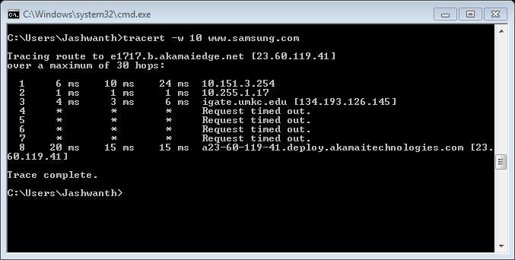

2.Using tracert command on [www.reebok.com](http://www.reebok.com) with option –d

Command entered: tracert –d [www.reebok.com](http://www.reebok.com)

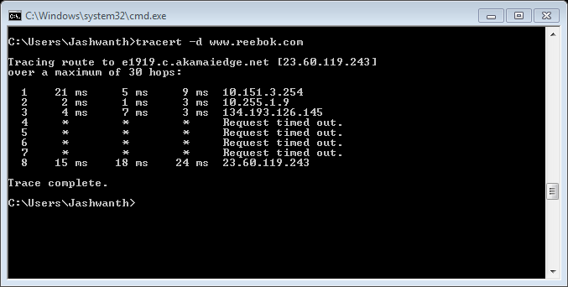

3. Using tracert command on www.nutrine.com with option –w timeout and -h maximum_hops

Command Entered: tracert –w 50 –h 30 [www.nutrine.com](http://www.nutrine.com)

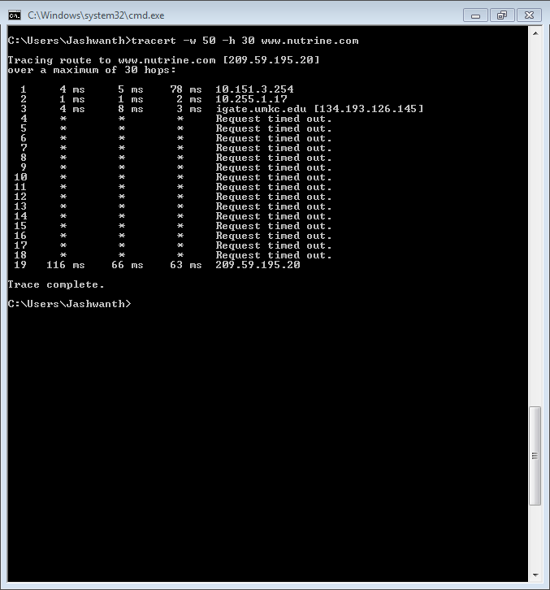

6. Explore ‘nslookup’ which is a program to query internet domain name servers particularly

a) Find out the IP address (es) of [www.cnn.com](http://www.cnn.com)

b) Find out the name servers and their IP addresses of umkc.edu.domain.

c) Find out the email servers and their IP addresses of umkc.edu.domain.

d) Try two other options.

Ans.

**Nslookup:**

Nslookup stands for name server lookup which is a program used to find out the corresponding IP address and host name.

1. The IP addresses of [www.cnn.com](http://www.cnn.com) are

157.166.226.25

157.166.226.26

157.166.255.18

157.166.255.19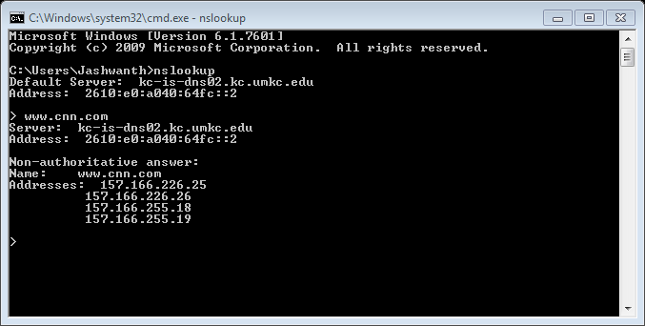

b) The name servers and IP addresses of umkc.edu.

ns1.umkc.edu

ns2.umkc.edu

ns3.umkc.edu

ns4.umkc.edu

ns5.umkc.edu

ns6.umkc.edu

kc-dc01.kc.umkc.edu

kc-dc02.kc.umkc.edu

kc-dc03.kc.umkc.edu

kc-dc06.kc.umkc.edu

kc-dc07.kc.umkc.edu

kc-dc04.kc.umkc.edu Address:134.193.126.161

kc-is-dns-02.kc.umkc.edu Address: 134.193.83.4

kc-is-dns-04.kc.umkc.edu Address: 134.193.1.2

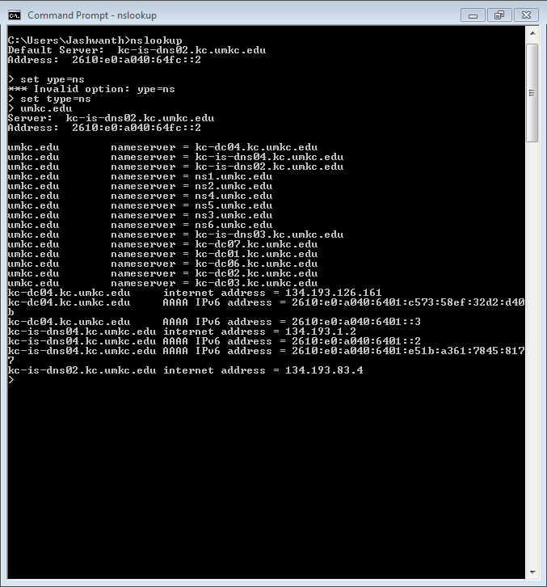

1. Email servers and IP addresses of umkc.edu

um-tedge1.um.umsystem.edu internet add: 207.160.158.135

um-tedge2.um.umsystem.edu internet add: 207.160.158.136

um-tedge3.um.umsystem.edu internet add: 207.160.158.137

um-nedge4.um.umsystem.edu internet add: 207.160.158.144

um-nedge5.um.umsystem.edu internet add: 207.160.158.145

um-nedge6.um.umsystem.edu internet add: 207.160.158.146

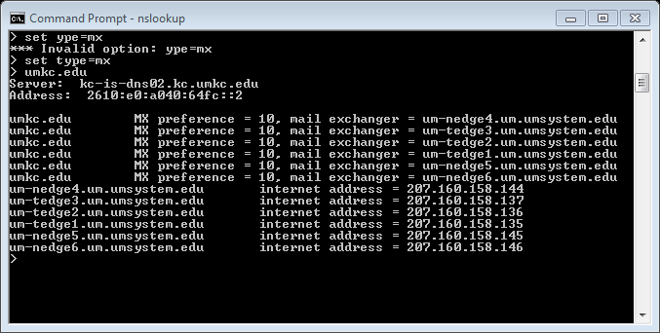

d)using two different host names

using nslookup for Vodafone.in with option PTR

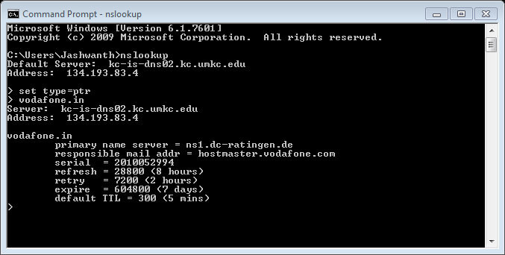

Using nslookup for [www.](http://www.)vemu.co.in with option SOA

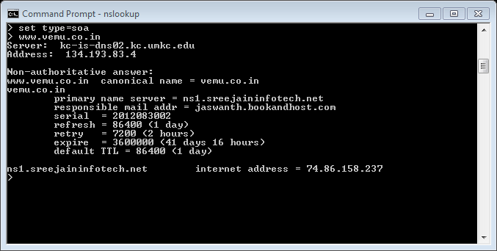

Some References used

1. [http://www.webopedia.com](http://www.webopedia.com/)
2. [http://computer.howstuffworks.com](http://computer.howstuffworks.com/)
3. [http://en.wikipedia.org](http://en.wikipedia.org/)
4. [http://virusall.com](http://virusall.com/)
5. <http://www.microsoft.com/security/pc-security/spyware-whatis.aspx>
6. <http://whatismyipaddress.com/spyware>
7. [http://www.speedguide.net](http://www.speedguide.net/)
8. [http://www.livinginternet.com](http://www.livinginternet.com/)
9. [http://www.cisco.com](http://www.cisco.com/)
10. [http://www.mediacollege.com](http://www.mediacollege.com/)
11. [http://www.computerhope.com](http://www.computerhope.com/)
12. [http://support.microsoft.com](http://support.microsoft.com/)
13. [http://www.guidingtech.com](http://www.guidingtech.com/)
14. <http://www.ibiblio.org/pioneers>
15. <http://www.ietf.org/>